hanging with mrbennette
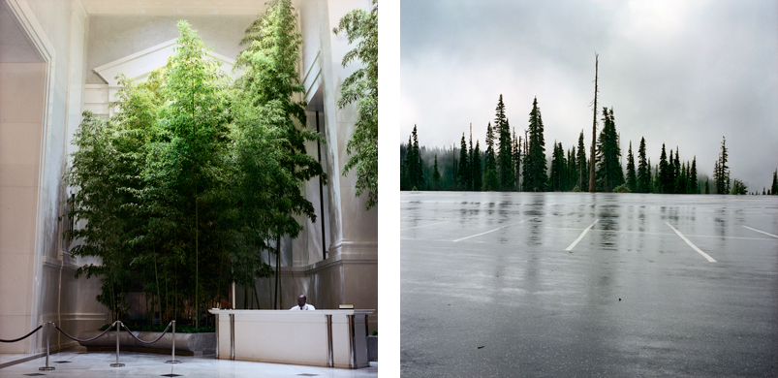

GO + SEE in MIAMI
COLEEN PLUMB
Toward the Sky Again, 1997-2011
Dina Mitrani Gallery + The Screening Room
Wynwood Art District, Miami Florida
2620 NW 2 Avenue. 786. 486. 7248

April 10 - May 31, 2014

In theory everything is going on here in New York this week but if you are not here visit a local gallery, look at art. Go outside and look at some trees smell the flowers and listen to the world around you.

That is how I met Colleen Plumb on a bright sunny day while in a restaurant looking out over central park my companion and I overheard a young couple speaking about photography and where to go and what to see?

Colleen was one of the voices speaking. Every now and then I check her website to see what she is doing. Her great opus is about relationships and perception of man with/against nature.

I think art is sometimes like life or music you establish a rhythm add a melody, some riffs and variations to expand the theme. This is very apparent in the diptychs which are a part of Colleens current exhibition Dina Mitrani Gallery

Looking Towards the Sky can best be explained by Coleen:
"From what (or where) do we draw strength and sustenance? Do artificial/mediated forms of nature offer a satisfying substitute for the actual? Where does wilderness begin and end? Towards The Sky Again looks at the ways humans engage with and make connections to the natural world. The images, made over a fourteen-year period (1997-2011) show interventions in the landscape and fabricated realities.

The built environment is full of cultivated natural forms, and the landscape around us has layer upon countless layer of human intervention. I am interested in these contradictions—the push-and-pull between interior and exterior worlds. The series looks to the elemental—terra (earth), aqua (water), aer (air), ignis (fire)—as reference, as a lead to something beyond the material, beyond human power."

Anyway I see these diptychs along with the videos that are also a part of this exhibition become a warm and stimulating visual chamber piece.

